August 2024
Editor: Robb KC9NNT
Amateur Radio Saves Lives
SEMO Amateur Radio Association KC0UYN POBox 1454, Poplar Bluff, MO 63902

President, Greg KC9WVR; Vice President, Robbie KE0TIL; Secretary, Mike KE0PEP; Treasurer Gary KD0FWH.
Trustees: Robb, KC9NNT, Russell KF5EPD and Ron KF0HMC
SEMOARA73@GMAIL.COM SemoHams.net

Our meetings are well attended and we seem to be testing after each meeting. There is a lot of new blood coming in the club, young guys that have great ideas for the club.

Bob KD0WCD is putting together a great book of members and friends radio stations, along with bios on “Why and how I got into radio” for new hams to look at and get ideas on setting up their own stations. As you know, a station can be as simple as a $30 hand held or a $5000+ base station. It just depends on your pocket book. Contact Bob at redneckintheozarks@icould.net with pictures of your station or bio.

EmCom trailer update: After inspecting the trailer, it has been determined that we need a new one. Water damage has messed up the insides. Dillon KD0PFQ is looking into prices and options. We will need to hold a few fundraisers to be able to afford the new and improved trailer.

Winter Field Day. We need volunteers to serve on the Field Day committee. It looks like we may get to set up at the public library on PP highway. Great for PR and internet available as well. Contact Robbie KE0TIL asap.

A fox hunt is planned for September 28 at Hendricks park. Time to be announced at the September meeting.

Antenna building party: Build an antenna on sept 21 at Robb KC9NNT’s house on September 21. 11 am. Bring the parts to build your antenna. J-Pole, Yagi, or portable. Research and bring the parts.

The 910 is on echo link. So you can check in from anywhere in the country. Program KD0PFQ-R into your echo link app.

Congrats to Clifford Ellis passing the Tech AND the General exams after the meeting Aug 8. We will be looking forward to hearing from him on the radio.

Listen to HF radio on your computer: http://kb0fxkiwisdr.hopto.org:8073/

July 2024 A.R.E.S. Report for Butler County: Check ins (QNI): 67. Traffic passed (QTC): 11. Emergency power 2. Storm watcher sessions: 0

The Amateur Radio Emergency Service® (ARES) consists of licensed amateurs who have voluntarily registered their qualifications and equipment, with their local ARES leadership, for communications duty in the public service when disaster strikes. Every licensed amateur, regardless of membership in ARRL or any other local or national organization is eligible to apply for membership in ARES. Training may be required or desired to participate fully in ARES. Please inquire at the local level for specific information. Because ARES is an amateur radio program, only licensed radio amateurs are eligible for membership. The possession of emergency-powered equipment is desirable but is not a requirement for membership. How to Get Involved in ARES: Fill out the ARES Registration form and submit it to your local Emergency Coordinator. Download the ARES® manual at: www.arrl.org/files/file/Public%20Service/ARES/ARESmanual2015.pdf
The ARRL Learning Center offers courses like on Basic EmComm and Intro to Radio for Emergencies & Disasters.

ARRL continues commitment and enhancements to existing advocacies:
  - Promoting Amateur Radio
  - Protecting Amateur Radio
Navajo Code Talkers Day is August 14, 2024, and recognizes the contributions of Navajo Marines during World War II. These “code talkers” encoded and transmitted messages using a complex Navajo language-based code. Secret communication was essential to the war and the code was never broken by Japanese forces in the Pacific. Special event station N7C will be in operation August 14 - 18, 0000Z - 0000Z, from Window Rock, Arizona, on 14.265, 7.265, and 18.133 MHz. A certificate & QSL card are available for $5.00 USD from Herbert Goodluck, N7HG, PO Box 06, Chinle, AZ 86503.
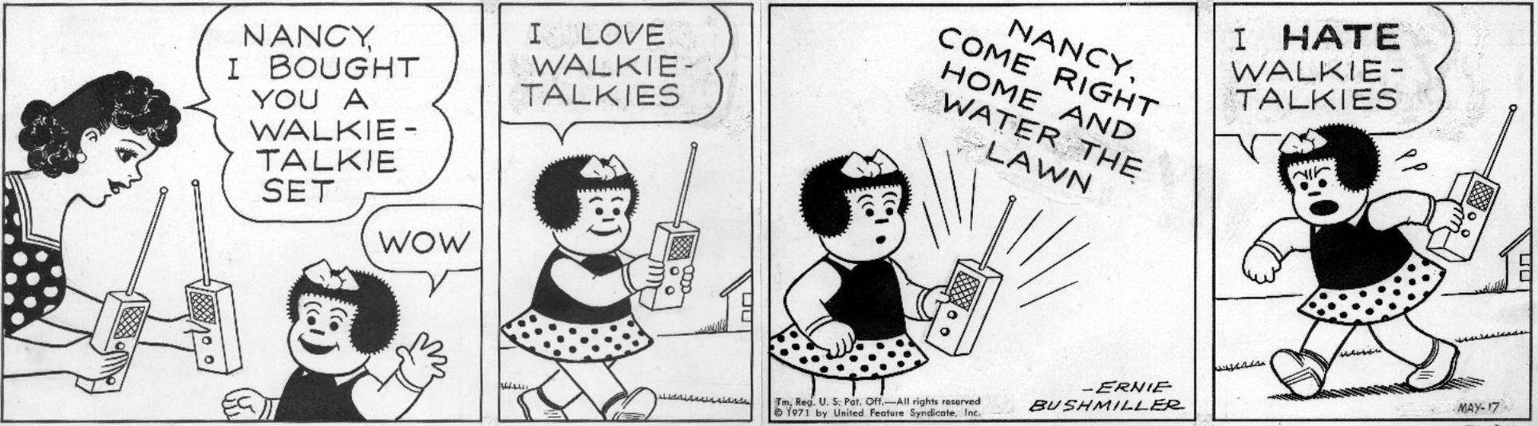
Test your memory: T9A02 Which of the following describes a type of antenna loading?
- A. Electrically lengthening by inserting inductors in radiating elements
- B. Inserting a resistor in the radiating portion of the antenna to make it resonant
- C. Installing a spring in the base of a mobile vertical antenna to make it more flexible
- D. Strengthening the radiating elements of a beam antenna to better resist wind damage

Answer at end of newsletter.

W1AW to change frequencies on 17-meters. Beginning on Friday, September 6, 2024, Maxim Memorial Station W1AW will begin using a new 17-meter frequency for its scheduled CW transmissions due to increased activity near the current bulletin frequency. In order to reduce the possibility of interference, W1AW will move to 18077.5 kHz.

HIPAA and Ham Radio. Two features of HIPAA are widely used by hams to support emergency communications and public service. One is the Red Cross exemption: The Red Cross and other volunteer groups are not recognized as healthcare providers, so there may be limited information sharing. This is a complex topic, however. The other provision allows a facility directory to share the location (only) of a person being treated. This is used as an example: Allowing the location (only) of an individual (often identified just by race bib number) at a marathon needing care to be relayed to health providers.

At a given scene or event, the healthcare providers might decide to use a secure Electronic Medical Records (EMR) type of system. Ham volunteers may or may not be invited to directly participate in that. At some events, hams have expressed concerns about the security required and have decided to disengage in the handling of secure data.

Please attend the “Free Advice” dutch treat breakfast Saturday after our SEMO ARA meeting. It’s at Hardees on Westwood Blvd at 8:30 am. Did I mention all advice is free!!

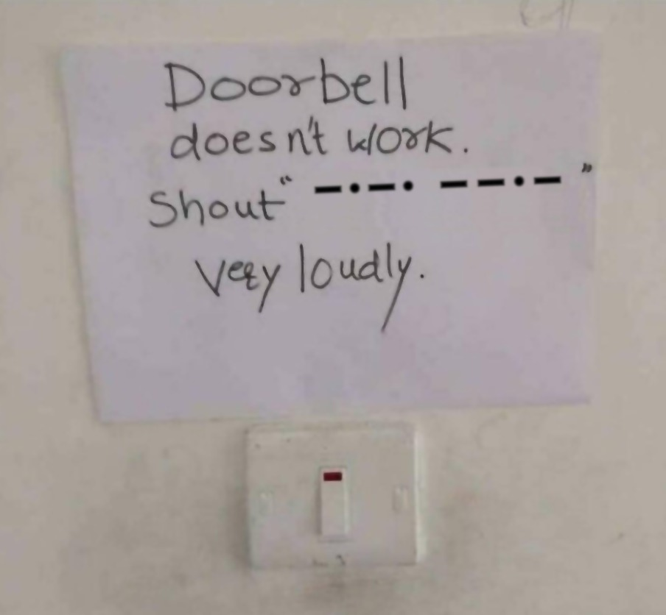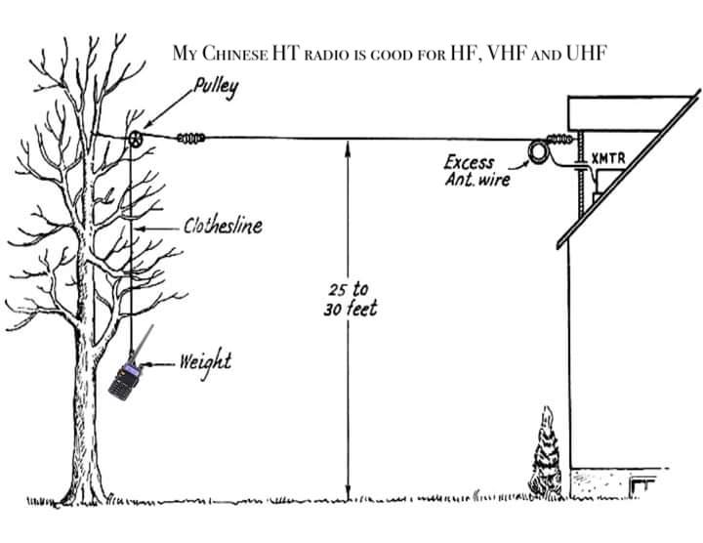

Remember our Ice Cream Social (dutch treat) at Burger King the 4th Tuesday each month at 6:30pm.

Training for EMCOMM is available at: http://www.arrl.org/emergency-communications-training

Get On the Air during VHF Contest Season

VHF contesting season is in full swing! Summer weather brings with it enhanced propagation. With good conditions, stations hundreds of miles away can be worked via tropospheric ducting, E-skip, and perhaps even meteor scatter. If you have an HF rig that includes 6 meters or VHF/UHF capability, you’ve got just the tools you need to take advantage of these enhancements! US amateurs of all license classes may participate in these events, so they are a great way for Technician-class hams to compete in contests.
There are several upcoming VHF+ contests coming up. The 2024 CQ World Wide VHF Contest is this weekend, beginning at 1800 UTC on Saturday, July 20 and concluding at 2100 UTC on Sunday, July 21. Participants can operate on the 6- and 2- meter bands.

The first of the VHF Fall Sprints, the 6-meter Sprint, will be held from 1800 – 2200 UTC on Saturday, August 10. The sprints continue in September with single-band events on 144, 222, and 432 MHz. The final sprint, held on Saturday, October 5, includes all bands 902 MHz and above.

For rules, see www.packratvhf.com/index.php/fall-sprints.

What to Do:
Before an explosion:
- Build an Emergency Supply Kit.
- Make a Family Emergency Plan.
- Learn how to identify suspicious activity and what to do in case of bomb threats.
- Make sure your employers have up-to-date information about any medical needs you may have and how to contact designated beneficiaries or emergency contacts.
- If you see something, say something. By being alert and reporting suspicious activity to your local law enforcement, you can help protect your family, neighbors and community.

During or Immediately After an Explosion
- Always follow the instructions of local officials. Emergency services may not be on scene right away.
- Remain calm. If things are falling around you, get under a sturdy table or desk.
- If it is safe to do so, leave the area as quickly as possible. Do not stop to retrieve personal possessions or make phone calls.
- Once you evacuate to safety, let your family emergency contact know you are safe by texting or messaging them on social media. Save phone calls for emergencies.
- Even if you are not directly involved in the explosion, stay informed and listen to local officials. You may be asked to evacuate or to turn off your electricity and water.
If you are inside, and able to evacuate:
- Check for fire and other hazards. Stay low if there is smoke.
- Do not use elevators. Avoid floors and stairways that are obviously weakened.
If you are trapped under debris:
- Use a flashlight, whistle or tap on pipes to signal your location to rescuers. Shout only as a last resort to avoid inhaling dust.
- Cover your nose and mouth with anything you have on hand.
If you are outside:
- Continue moving away from the area to safety.
- You may be the help until help arrives. If it is safe to do so, help people get to safety.
- If you know where people are trapped, do not attempt to rescue them as moving debris could cause further harm. Once emergency services are on scene, immediately notify them.

Related Content
- If You See Something, Say Something (DHS)
- What to Do - Bomb Threat (CISA)

Area Nets (All times central USA time zone unless otherwise indicated)

Monday
Stoddard County ARES net 2nd Monday monthly, 6 pm 147.150+ 100 pl
The Missouri ARES® District E Training and Traffic net 7 pm on 147.330 pl tone 100.0 (Bloomfield)
Missouri DMR Net 7 pm on talk group 31291
SEMO ARA Butler Co ARES check-in net at 7:30 pm on 145.350 pl 100.0
Missouri DMR Net 7:30 pm on talk group 3129
SEMO ARA Butler Co ARES net at 8 pm on 146.910 pl 100.0
Missouri DMR net 8pm TG 3129

Tuesday
Piedmont Net at 7 pm on 147.375 pl 100
Current River net 7:30 pm on 146.865 pl 100

Wednesday
SEMO ARA Learn Morse Code Net about 5:45 pm on 146.495
SEMO DMR rag chew 6:30pm talk group 31295

Thursday
The Missouri ARES® District E Training and Traffic net 7 pm on the 146.910 pl tone 100.0 (Poplar Bluff)
Doniphan net 7:30 pm on 146.865 pl 100
Greenville Net 8 pm on 145.230 pl 123
Bootheel ARC, Kennett Net 8 pm on 146.985 pl 100
Digital Thursday net about 8:15 pm on 145.13 & 145.31(no pl tone needed)

Friday
SEMO ARA Learn Morse Code Net about 5:30 pm on 146.495

Sunday
The PBW-Net humanitarian 8 pm on simplex 146.495
SEMO ARA Learn Morse Code Net about 8:15 pm on 146.495
SEMO Emergency Net 7 pm first Sunday each month 28.400 USB

FORMAL TRAFFIC, TRAINING or ROLL CALL NETS (must have a general or higher license)

Missouri Traffic Net nightly 5:30 pm 3.963 (5 pm winter hours)
Missouri Emergency Services Net 2 pm Sunday on 3.963 MHz+/- or 7.263 MHz +/-
Illinois Sideband Traffic Net nightly at 6 pm on 3.905
Illinois ARES net First and Third Sunday 4:30pm 3.905
Arkansas Razorback Traffic net nightly 6:30pm 3.987.5
Country Cousins Net. Daily 9:00 pm 3.970
Ham Butchers. weekdays 11:30 am. 7.280
Frisco Net. Saturday. 9 am 3.922 or 3.915 depending on conditions
Kadiddlehoppers daily (except Sunday) 12:30 pm 7.253.5
Hurricane watch net on 7.268.00 MHz

NOAA emergency radio frequencies: 163.275, 162.55, 162.525, 162.50, 162.475, 162.45, 162.425, 162.40

Emergency radio frequencies you may need at one time or another:
  - – Military national disaster preparedness frequency
  - -163.4875 – National Guard emergency communications frequency
  - -156.80 – International maritime distress channel
156.75 – International maritime weather alerts
155.475 – Emergency communications for police
155.160 – Used by various agencies during search and rescue operations
154.295 – Used by firefighters during emergencies
154.28 – Used by firefighters during emergencies
154.265 – Used by firefighters during emergencies
138.225 – Disaster relief channel used by FEMA
121.50 – International frequency for aeronautical emergencies
47.42 – Nationwide Red Cross channel during humanitarian aid missions
39.46 – Inter-department emergency communications by police
34.90 – Nationwide National Guard frequency during emergencies

One way to communicate with family members during an emergency situation when cellphones are not working is through CB (Citizens’ Band) radio. No license is needed to send or receive communications. Combined with a family disaster plan, it will aid you greatly if cellphone towers stop working. There are 40 separate channels that CB radios operate on. The only one to avoid is Channel 9, which is reserved for the Emergency/REACT channel.
One thing to keep in mind is that your conversations while using CB radio will not be secure. Bad guys could be on the same channel at the same time.
Among the other channels are:
Channel 37 – Unofficial Prepper 37 (USB)
Channel 36 – Unofficial Survivalist network
Channel 19 – Used by truckers headed east or west
Channel 17 – Used by truckers headed north or south
Channel 13 – Typically used within campgrounds and marine areas
Channel 4 – Unofficial American Preppers Network
Channel 3 – Unofficial Prepper CB Network
Plan for emergencies at ready.gov and providentliving.org
Unfortunately, only 20% of US hams are members of ARRL. ARRL is our voice in Washington. They lobby for our rights and privileges to be amateur radio operators. Yes, they have their issues, but the advantages far outweigh the issues you may perceive they have. Join or Renew Today! All ARRL members can access digital editions of all four ARRL magazines: QST, On the Air, QEX, and NCJ.
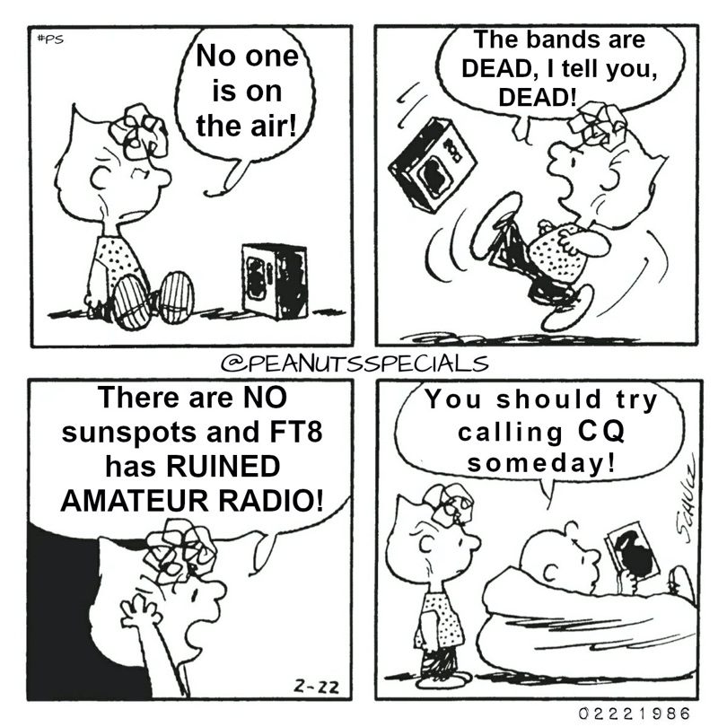

ARRL Resumes Accepting Life Membership Applications. ARRL is again accepting new applications for Life Membership. Applications for Life Membership were paused last year, pending the approval of an adjusted, revenue-neutral program. Life Membership rates have now been established based on the current term dues amount and the applicant's age (requires verification). Payment can be made in full, or paid in 24 - monthly installments by credit card. ARRL Life Membership includes the benefits of membership for life. Print magazine subscriptions are sold separately. Visit the ARRL website for a complete list of dues rates. Life Membership can be purchased at www.arrl.org/join (current members should login to the ARRL website first).

As always, we need help with our numerous committees. Please contact a committee chair to join, or Greg KC9WVR (club president) to chair a committee (or start one).

Do you have an item for the News Letter? Email it to KC9NNT@ARRL.NET

- Answer to test your memory : A. Electrically lengthening by inserting inductors in radiating elements.

