SEMO ARA NEWSLETTER
May 2024
Editor: Robb KC9NNT
Amateur Radio Saves Lives
SEMO Amateur Radio Association KC0UYN POBox 1454, Poplar Bluff, MO 63902

President, Greg KC9WVR; Vice President, Robbie KE0TIL; Secretary, Mike KE0PEP; Treasurer Gary KD0FWH.
Trustees: Robb, KC9NNT, Russell KF5EPD and Ron KF0HMC
SEMOARA73@GMAIL.COM

2024 ARRL Field Day is June 22-23 Field Day is ham radio's open house. Every June, more than 40,000 hams throughout North America set up temporary transmitting stations in public places to demonstrate ham radio's science, skill and service to our communities and our nation. It combines public service, emergency preparedness, community outreach, and technical skills all in a single event. Field Day has been an annual event since 1933 and remains the most popular event in ham radio. SEMO ARA will perform Field Day at Fellowship General Baptist Church on the north end of Poplar Bluff. (Same place as last year.)
Shane KD0ZED took and passed the General exam today. Congrats to KD0ZED-GE.

We have replaced the sign on the right side of the trailer. Thanks to all those who had a hand in this. 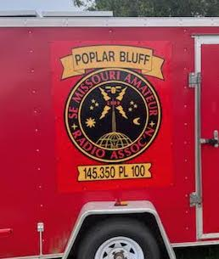

During Field Day, the club will clean up the inside of the trailer. There are several things that can be given away and a few things that club members may be able to store at their homes.

From ARRL: Storms and Tornadoes: Amateur Radio Ready
Strong storms and reports of at least 60 tornadoes have wreaked havoc in the Central U.S. for nearly two weeks. Homes and businesses across Nebraska, Oklahoma, Texas, Missouri, and Iowa were destroyed, and power is still down for more than 30,000 residents.
Section Manager of the ARRL Iowa Section Lelia Garner, WA0UIG, reported that in Iowa, they have moved from response to recovery. Currently, nine counties are under the Iowa State Individual Assistance Grant Program and the Disaster Case Advocacy Program.
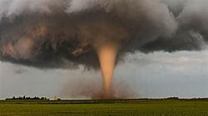
Iowa Tornado 2024 [NOAA photo]
"Amateur Radio has served our local agencies well. We recently networked at a central Iowa hamfest and are building our emergency communications capacity primarily through [the Amateur Radio Emergency Service® (ARES®). ARES resources [include] personnel, experience, meetings, training, [communications] equipment, [and] operating trailers. The opportunity to share our experience and knowledge gained in the field has been critical to supporting ARES in Iowa," said Garner.
Garner added that awareness is the best tool. She stressed that amateur operators and ARES members work to help the National Weather Service and other served agencies in order make their work and the community safer.
ARRL Emergency Management Director Josh Johnston, KE5MHV, agrees that everyone should stay vigilant in their awareness and preparations, even during periods of less activity. Make sure you are prepared at home and that your family has a severe weather plan. This is extremely important if you plan to be mobile or away from your home during a severe weather event. Your safety is the most important thing if you plan to be active during severe weather. Every ham who is interested in severe weather should take the SKYWARN storm spotting class offered by the National Weather Service," said Johnston.
He added that some of the most important aspects of preparation are communication and building relationships. These activities, including drills and exercises, need to be done during blue - sky days to ensure you will be ready during days with severe weather.
The ARRL Learning Center offers courses like on Basic EmComm and Intro to Radio for Emergencies & Disasters.

Listen to HF radio on your computer: http://kb0fxkiwisdr.hopto.org:8073/

A huge thank you to Stan, KD0STN, for a donation of a 40 foot antenna mast. It will come in handy at Field Day and other events.

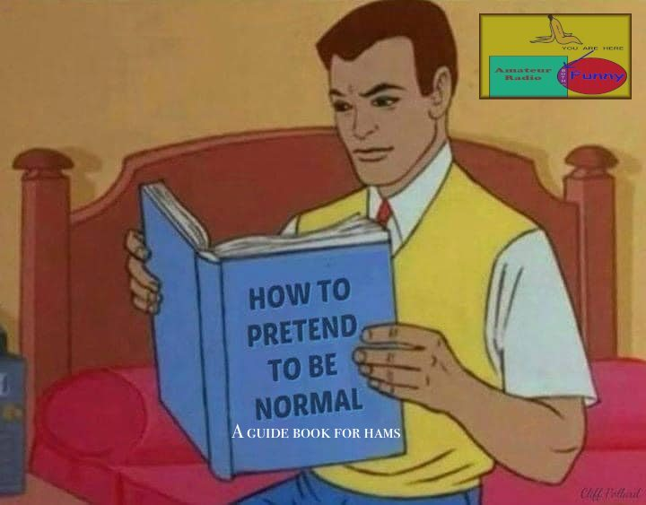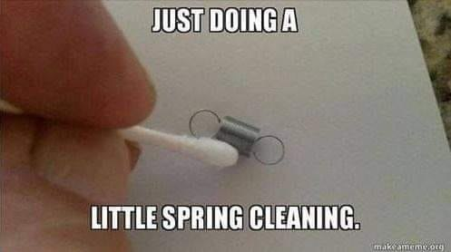


Armed Forces Day Crossband Test May 11, 2024
The US Department of Defense will host this year's Armed Forces Day (AFD) Crossband Test on May 11, 2024. For more than 50 years, military and amateur stations have taken part in this event, which is an interoperability exercise between hobbyist and government radio stations. The event is open to all licensed amateur radio operators and will not impact any public or private communications. The AFD Crossband Test is a unique opportunity to test two-way communications between military communicators and radio stations in the Amateur Radio Service (ARS), as authorized in 47 CFR 97.111.
These tests provide opportunities and challenges for radio operators to demonstrate individual technical skills in a tightly controlled exercise scenario. Military stations will transmit on selected military frequencies and announce the specific ARS frequencies monitored. All scheduled times will be in Zulu (Z), and all scheduled frequencies will be upper sideband (USB) unless otherwise noted.
Information on frequencies, times, and other technical information can be found at DoD MARS - Armed Forces Day. Information for QSL cards and contact information is available at Armed Forces Day QSL request form.

Our POTA event had a few good amateurs attending and unfortunately the bands did not cooperate. We did qualify the event with 10 contacts, but they were hard earned.

Bob, KD0WCD, is putting together a folder for new hams to view. The folder will have pictures of amateur radio stations with some background info, approximate prices, type of coax or feed line, kinds of antennas used, etc. Please help Bob out and send him some pics of your radio station, or mobile or HT. Send to RedNeckInTheOzarks@iCloud.com
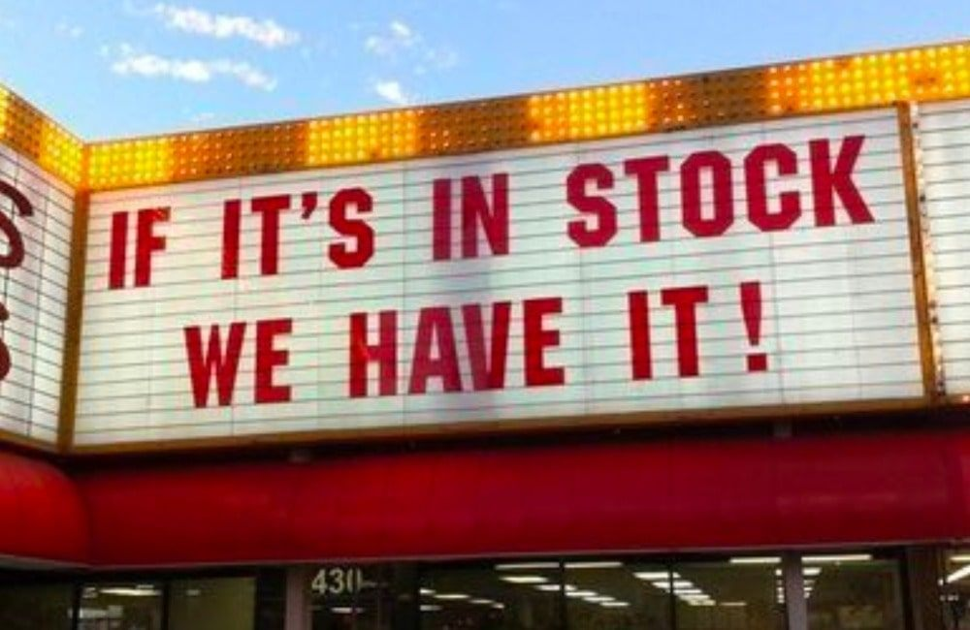

April 2024 A.R.E.S. Report for Butler County: Check ins (QNI): 68. Traffic passed (QTC): 9. Emergency power 4.

Download the ARES® manual at: www.arrl.org/files/file/Public%20Service/ARES/ARESmanual2015.pdf

Test your memory: T1D01 With which countries are FCC-licensed amateur radio stations prohibited from exchanging communications?
A. Any country whose administration has notified the International Telecommunication Union (ITU) that it objects to such communications
B. Any country whose administration has notified the American Radio Relay League (ARRL) that it objects to such communications
C. Any country banned from such communications by the International Amateur Radio Union (IARU)
D. Any country banned from making such communications by the American Radio Relay League (ARRL)

Answer at end of newsletter.

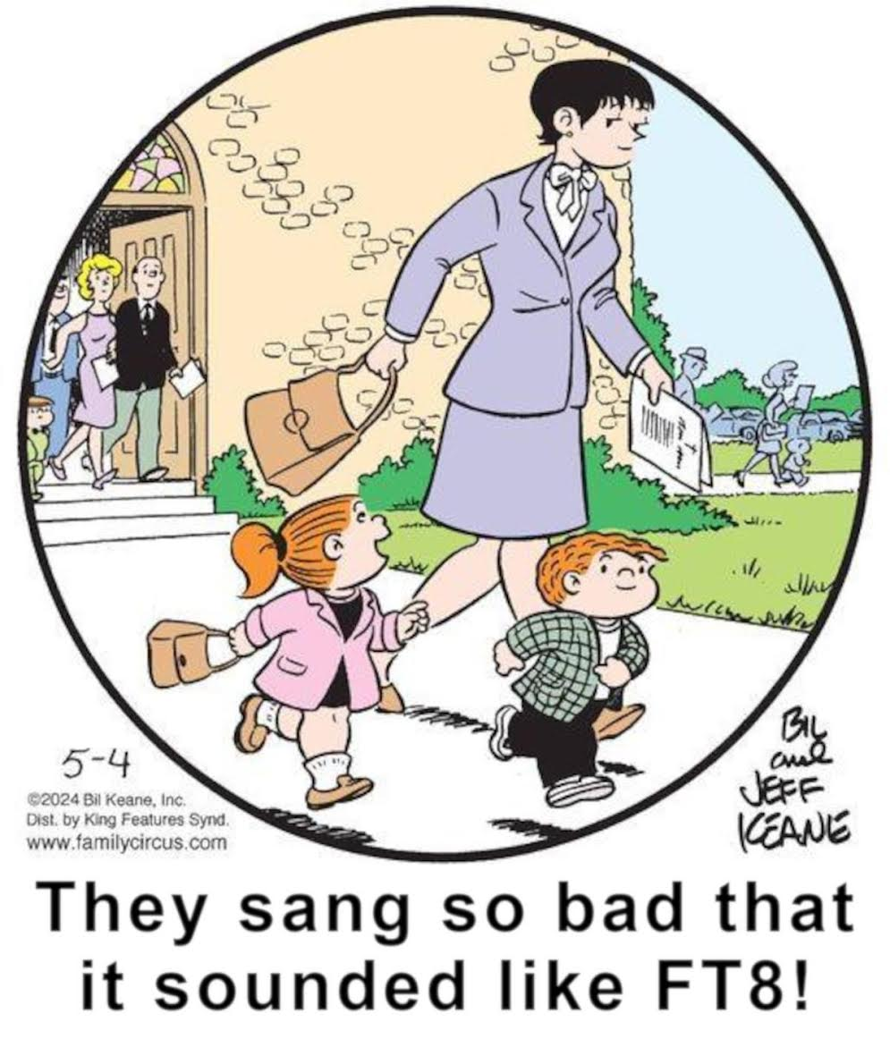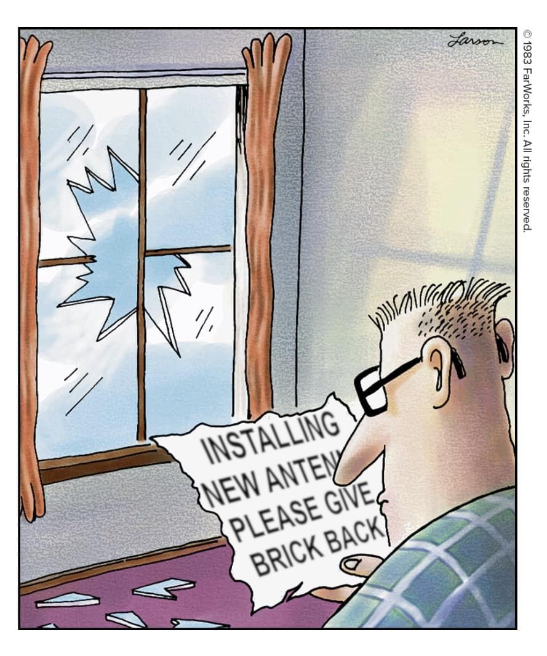

Please attend the Free Advice dutch treat breakfast Saturday after our SEMO ARA meeting. It’s at Hardees on Westwood Blvd at 8:30 am. Did I mention all advice is free!!

Remember our Ice Cream Social (dutch treat) at Burger King the 4th Tuesday each month at 6:30pm.

The third annual Lewis and Clark Trail on the Air will be active from June 1 - 16. This special event is an on-air activity that commemorates the historic Lewis and Clark National Historic Trail, which covers 4,900 miles through 16 states, including the disembarkation from Camp Dubois and what is referred to as the Eastern Legacy. The event is sponsored by the Clark County Amateur Radio Club (CCARC), W7AIA, with support and participation from various clubs in all 16 states along the historic trail. Each day of the event runs for 24, hours and the start time is 0000 UTC through 2400 UTC. Operating modes include SSB phone, FM phone, CW, and FT8. Any combination of modes toward working all 16 states is allowed. A schedule for planned operations for each participating state will be posted on the CCARC website. Certificates can be requested for two classes of participation: the Expedition Partner Certificate (awarded to any station working all 16 states) and the Trail Companion Certificate (awarded to any station working one or more states). Clubs interested in activating this event for one of the 16 states of the Lewis and Clark National Historic Trail should send an email of interest to info@LCTOTA.org.

Training for EMCOMM is available at: http://www.arrl.org/emergency-communications-training

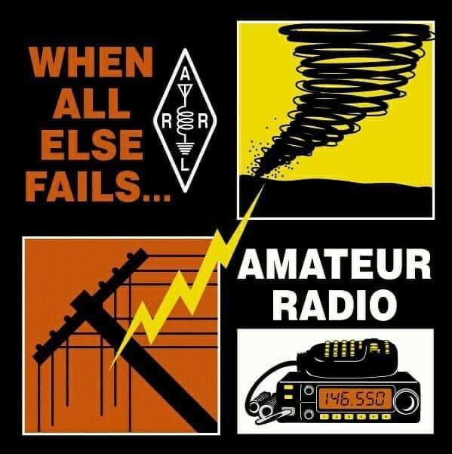

If you know anyone who would like to get their Amateur Radio license, have them email me at KC9NNT@ARRL.NET and register for the classes beginning June 4 on ZOOM.

Area Nets (All times central USA time zone unless otherwise indicated)

Monday
Stoddard County ARES net 2nd Monday monthly, 6 pm 147.150+ 100 pl
The Missouri ARES® District E Training and Traffic net 7 pm on 147.330 pl tone 100.0 (Bloomfield)
Missouri DMR Net 7 pm on talk group 31291
SEMO ARA Butler Co ARES check-in net at 7:30 pm on 145.350 pl 100.0
Missouri DMR Net 7:30 pm on talk group 3129
SEMO ARA Butler Co ARES net at 8 pm on 146.910 pl 100.0
Missouri DMR net 8pm TG 3129

Tuesday
Piedmont Net at 7 pm on 147.375 pl 100
Current River net 7:30 pm on 146.865 pl 100

Wednesday
SEMO ARA Learn Morse Code Net about 5:45 pm on 146.495
SEMO DMR rag chew 6:30pm talk group 31295

Thursday
The Missouri ARES® District E Training and Traffic net 7 pm on the 146.910 pl tone 100.0 (Poplar Bluff)
Doniphan net 7:30 pm on 146.865 pl 100
Greenville Net 8 pm on 145.230 pl 123
Bootheel ARC, Kennett Net 8 pm on 146.985 pl 100
Digital Thursday net about 8:15 pm on 145.13 & 145.31(no pl tone needed)

Friday
SEMO ARA Learn Morse Code Net about 5:30 pm on 146.495

Sunday
The PBW-Net humanitarian 8 pm on simplex 146.495
SEMO ARA Learn Morse Code Net about 8:15 pm on 146.495
SEMO Emergency Net 7 pm first Sunday each month 28.400 USB

FORMAL TRAFFIC, TRAINING or ROLL CALL NETS (must have a general or higher license)

Missouri Traffic Net nightly 5:30 pm 3.963 (5 pm winter hours)
Missouri Emergency Services Net 2 pm Sunday on 3.963 MHz+/- or 7.263 MHz +/-
Illinois Sideband Traffic Net nightly at 6 pm on 3.905
Illinois ARES net First and Third Sunday 4:30pm 3.905
Arkansas Razorback Traffic net nightly 6:30pm 3.987.5
Country Cousins Net. Daily 9:00 pm 3.970
Ham Butchers. weekdays 11:30 am. 7.280
Frisco Net. Saturday. 9 am 3.922 or 3.915 depending on conditions
Kadiddlehoppers daily (except Sunday) 12:30 pm 7.253.5
Hurricane watch net on 7.268.00 MHz

NOAA emergency radio frequencies: 163.275, 162.55, 162.525, 162.50, 162.475, 162.45, 162.425, 162.40

Emergency radio frequencies you may need at one time or another:
  - – Military national disaster preparedness frequency
  - -163.4875 – National Guard emergency communications frequency
  - -156.80 – International maritime distress channel
156.75 – International maritime weather alerts
155.475 – Emergency communications for police
155.160 – Used by various agencies during search and rescue operations
154.295 – Used by firefighters during emergencies
154.28 – Used by firefighters during emergencies
154.265 – Used by firefighters during emergencies
138.225 – Disaster relief channel used by FEMA
121.50 – International frequency for aeronautical emergencies
47.42 – Nationwide Red Cross channel during humanitarian aid missions
39.46 – Inter-department emergency communications by police
34.90 – Nationwide National Guard frequency during emergencies

One way to communicate with family members during an emergency situation when cellphones are not working is through CB (Citizens’ Band) radio. No license is needed to send or receive communications. Combined with a family disaster plan, it will aid you greatly if cellphone towers stop working. There are 40 separate channels that CB radios operate on. The only one to avoid is Channel 9, which is reserved for the Emergency/REACT channel.
One thing to keep in mind is that your conversations while using CB radio will not be secure. Bad guys could be on the same channel at the same time.
Among the other channels are:
Channel 37 – Unofficial Prepper 37 (USB)
Channel 36 – Unofficial Survivalist network
Channel 19 – Used by truckers headed east or west
Channel 17 – Used by truckers headed north or south
Channel 13 – Typically used within campgrounds and marine areas
Channel 4 – Unofficial American Preppers Network
Channel 3 – Unofficial Prepper CB Network

NOTEWORTHY WEBSITES
ARRL Hamfest and Convention list arrl.org/hamfests/search
CountyHunter.com for cw contesting and info
Ed’s (AD0WN) Tri-State Repeater list http://semoarc.com/nets.htm
NWS SKYWARN SPOTTER TRAINING schedule weather.gov/pah/spottertraining
SARA CLUB w9rnm.org
SEMO Amateur Radio Association SEMOHAMS.NET
Topographical Maps heywhatsthat.com
TRI STATE AMATEUR RADIO SOCIETY w9og.net
W0AVQ’s Repeater Overlay on Google Earth http://hamradio.w0avq.org/repeaters
W9RY SOUTHERN IL. AMATEUR RADIO PAGE w9ry.com
Weather forecasting related Windy.com
Plan for emergencies at ready.gov and providentliving.org
Unfortunately, only 20% of US hams are members of ARRL. ARRL is our voice in Washington. They lobby for our rights and privileges to be amateur radio operators. Yes, they have their issues, but the advantages far outweigh the issues you may perceive they have.

Join or Renew Today! All ARRL members can access digital editions of all four ARRL magazines: QST, On the Air, QEX, and NCJ.

ARRL Resumes Accepting Life Membership Applications. ARRL is again accepting new applications for Life Membership. Applications for Life Membership were paused last year, pending the approval of an adjusted, revenue-neutral program. Life Membership rates have now been established based on the current term dues amount and the applicant's age (requires verification). Payment can be made in full, or paid in 24 - monthly installments by credit card. ARRL Life Membership includes the benefits of membership for life. Print magazine subscriptions are sold separately. Visit the ARRL website for a complete list of dues rates. Life Membership can be purchased at www.arrl.org/join (current members should login to the ARRL website first).
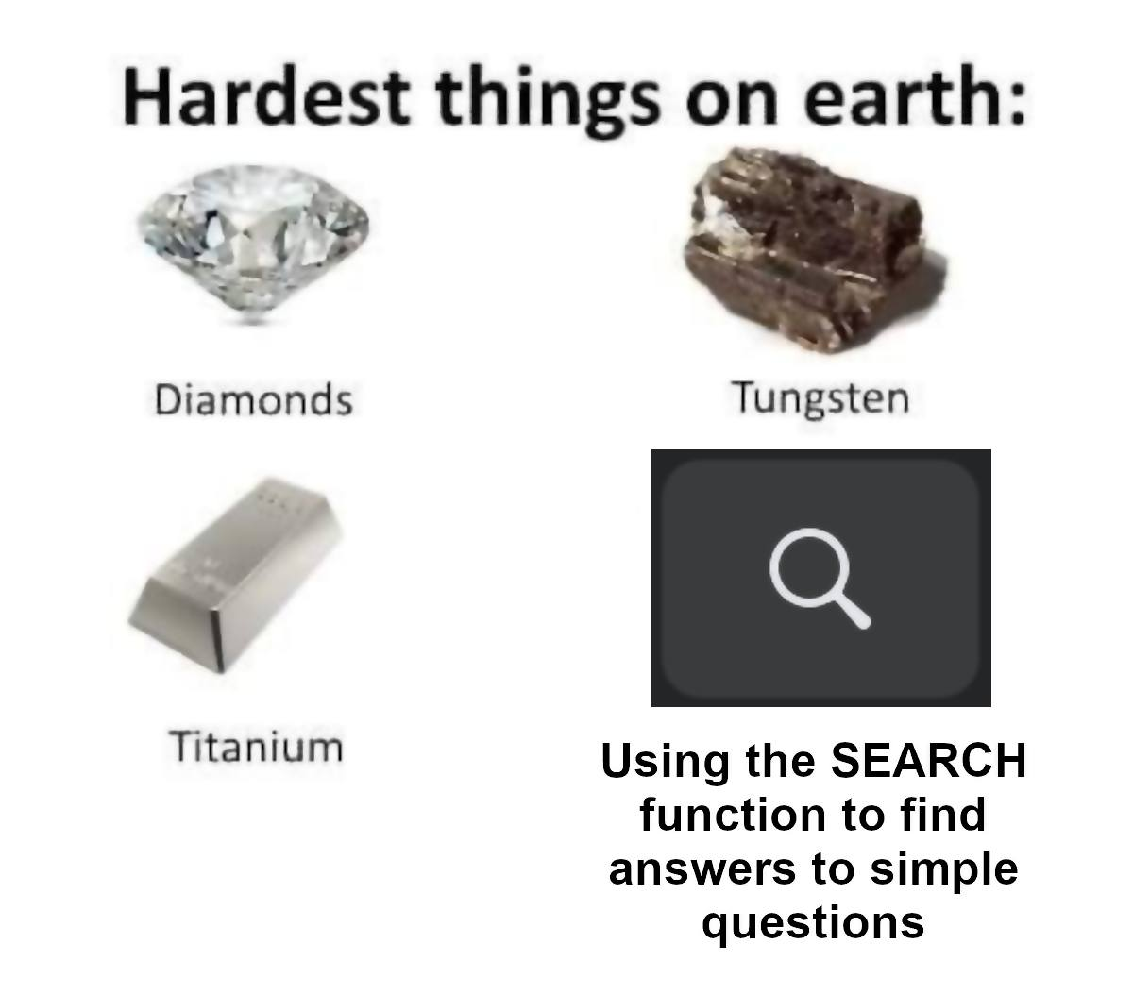
As always, we need help with our numerous committees. Please contact a committee chair to join, or Greg KC9WVR (club president) to chair a committee (or start one).

Do you have an item for the News Letter? Email it to KC9NNT@ARRL.NET

- Answer to test your memory : A. Any country whose administration has notified the International Telecommunication Union (ITU) that it objects to such communications

